**PIZZA SALES SQL QUESRIES**

**A. KPI’s**

**1. Total Revenue:**

SELECT SUM(total_price) AS Total_Revenue FROM pizza_sales;

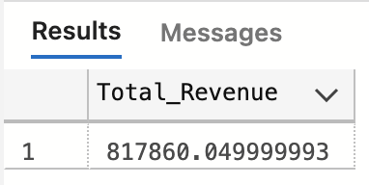

**2. Average Order Value**

SELECT SUM(total_price) / COUNT(DISTINCT order_id) as Avg_Order_Value from pizza_sales;

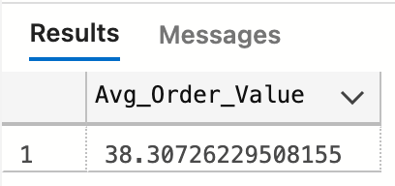

**3. Total Pizzas Sold**

SELECT SUM(quantity) AS Total_Pizza_Sold FROM pizza_sales;

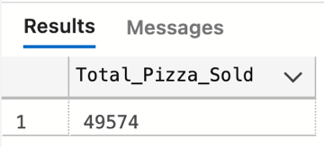

**4. Total Orders**

SELECT COUNT(DISTINCT order_id) AS Total_Orders FROM pizza_sales;

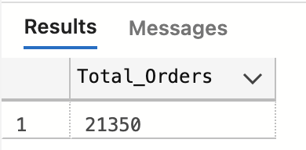

**5. Average Pizzas Per Order**

SELECT CAST(CAST(SUM(quantity) AS DECIMAL(10,2)) /

CAST(COUNT(DISTINCT order_id) AS DECIMAL(10,2)) AS DECIMAL (10,2)) AS Avg_Pizza_Per_Order FROM pizza_sales;

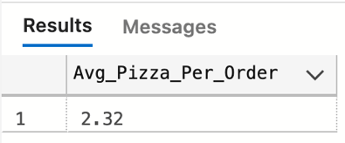

**CHARTS REQUIREMENT**

**1. Hourly Trend for Total Orders**

SELECT DATEPART(HOUR, order_time) AS order_hour, SUM(quantity) AS Total_Pizzas_Sold

FROM pizza_sales

GROUP BY DATEPART(HOUR, order_time)

ORDER BY DATEPART(HOUR, order_time);

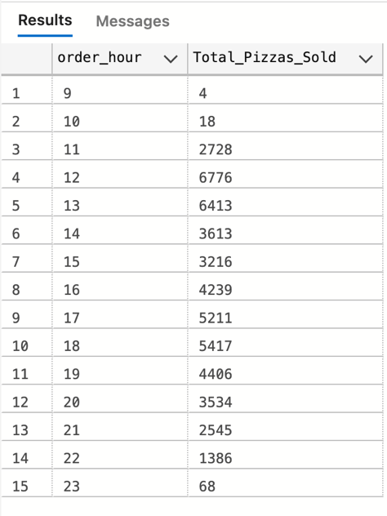

**2. Weekly Trend for Total Orders**

SELECT DATEPART(ISO_WEEK, order_date) AS Week_Number, YEAR(order_date) AS Order_Year,

COUNT(DISTINCT order_id) AS Total_Orders FROM pizza_sales

GROUP BY DATEPART(ISO_WEEK, order_date), YEAR(order_date)

ORDER BY DATEPART(ISO_WEEK, order_date), YEAR(Order_date);

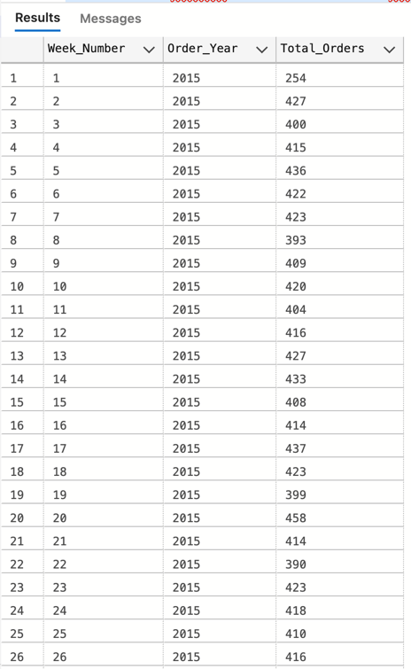 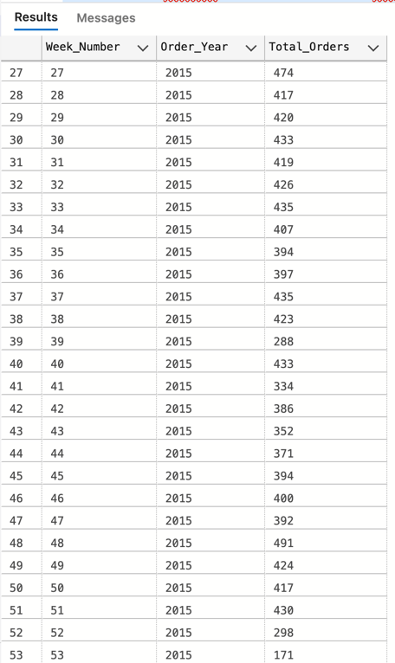

**3. Percentage of sales by pizza category**

SELECT pizza_category, SUM(total_price) AS Total_Sales, SUM(total_price) * 100 /

(SELECT SUM(total_price) from pizza_sales WHERE MONTH(order_date) = 1)AS PCT

from pizza_sales

WHERE MONTH(order_date) = 1

GROUP BY pizza_category;

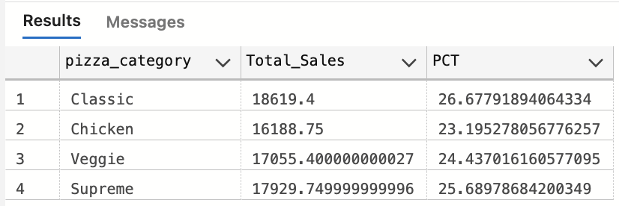

**4. Percentage of sales by pizza size**

SELECT pizza_size, CAST(SUM(total_price) AS DECIMAL (10,2)) AS Total_Sales, CAST (SUM(total_price) * 100 /

(SELECT SUM(total_price) from pizza_sales WHERE DATEPART(QUARTER, order_date) = 1) AS DECIMAL (10,2)) AS PCT

from pizza_sales

WHERE DATEPART(QUARTER, order_date) = 1

GROUP BY pizza_size

ORDER BY PCT DESC ;

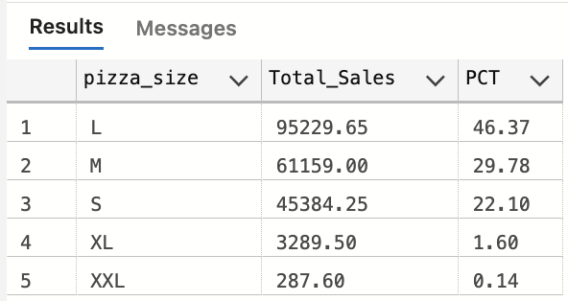

**5. Top 5 Pizzas by Revenue**

SELECT TOP 5 pizza_name, SUM(total_price) AS Total_Revenue from pizza_sales

GROUP BY pizza_name

ORDER BY Total_Revenue DESC

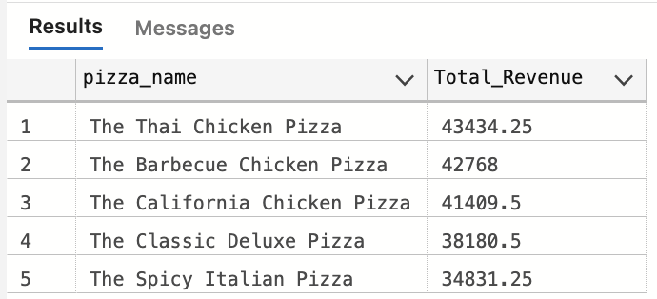

**6. Bottom 5 Pizzas by Revenue**

SELECT TOP 5 pizza_name, SUM(total_price) AS Total_Revenue from pizza_sales

GROUP BY pizza_name

ORDER BY Total_Revenue

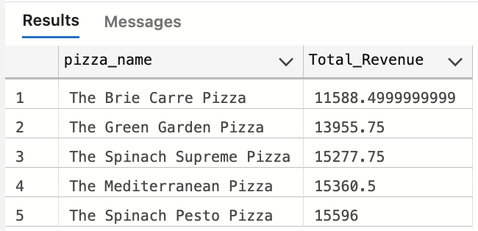

**7. Top 5 Pizzas by Quantity**

SELECT TOP 5 pizza_name, SUM(quantity) AS Total_Quantity from pizza_sales

GROUP BY pizza_name

ORDER BY Total_Quantity DESC

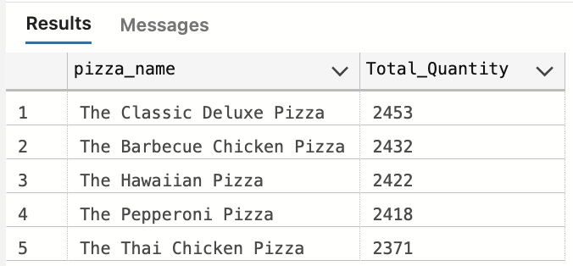

**8. Bottom 5 Pizzas by Quantity**

SELECT TOP 5 pizza_name, SUM(quantity) AS Total_Quantity from pizza_sales

GROUP BY pizza_name

ORDER BY Total_Quantity

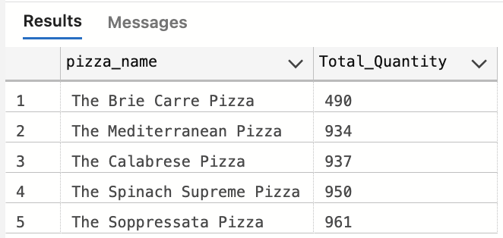

**9. Top 5 Pizzas by Orders**

SELECT TOP 5 pizza_name, COUNT(DISTINCT order_id) AS Total_Order from pizza_sales

GROUP BY pizza_name

ORDER BY Total_Order DESC

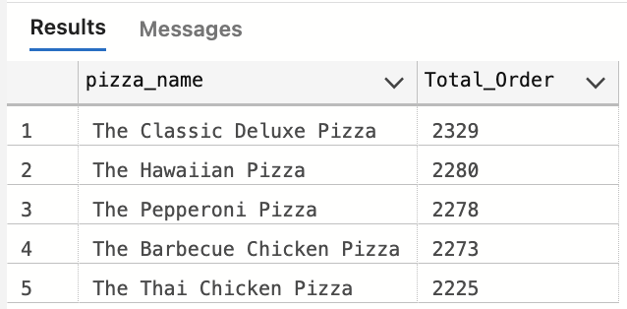

**10. Bottom 5 Pizzas by Orders**

SELECT TOP 5 pizza_name, COUNT(DISTINCT order_id) AS Total_Order from pizza_sales

GROUP BY pizza_name

ORDER BY Total_Order

